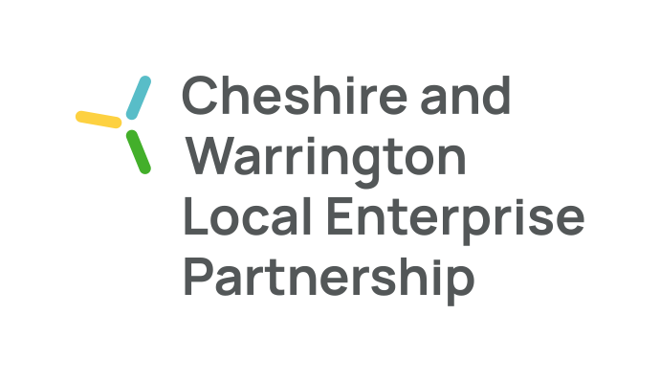
Notes for Engagement Board Meeting 1st April 2022

The following people attended the meeting:
- Maggie Chen- (Chair)
- Yulanda Duff - (Deputy Chair)
- Katie McConnell
- Joe Toward
- Alice Choi
- Andy Devaney
- Kirstin McCallum

Apologies:
- Connor Diskin

The main purpose of the meeting is to:
- Receive and comment on presentation delivered by Alice and Andy which will be the topic for the Main Board Discussion Forum
- Reflect on the North West Net Zero Youth Network opportunity
- Deliver overview of the outcomes of the last main board meeting

Meeting Notes

17.00 hrs Welcome, introductions with members and guests (10 mins)
- Welcome by Maggie
- Introductions by all attendees

17.10 hrs Business Growth & the Environment Presentation by Alice and Andy, followed by (30 minutes)
- It was noted that the Growth Hub budget is now in and is 50% less than expected. This means the focus needs to be adjusted to make sure the budget can go to where it will make the most impact
- Growth Hub YTD – there was focus on keeping businesses afloat during the pandemic, but now it is moving into the growth phase post Covid-19
- The successes of the Growth Hub included working with 1200 unique businesses as well as 10 Peer Network cohorts being initiated. The final case studies and reports are pending. There are also 200 support partners on board.
- The main areas of focus for the Growth Hub in the coming financial year were broken down as follows:
- Finance - Businesses are looking for access to finance and this is a main area of support for the Growth Hub (case studies available)
- Innovation – supporting 200 cross sector businesses with innovation projects (product, process, service, business model)
- Economic & Business intelligence – gathering information on hot topics like Covid, trading exports and imports and their outcomes. This information has a direct line to govt – showing inward and outward support
- BEIS outputs will be coming in soon – provision of valuable grwth enabling tools and resources. Aiming to support with access to finance, R&D and innovation, ED&I, CRM. The Growth Hub will also be engaging with the wider network and working with partners across the Northwest
- The Growth Hub are seeing a skills gap in recruitment – it is hard to recruit for technical skills but is also a big opportunity for businesses to get ahead with focused recruitment
- Purpose pyramid – strategically what the committee hope to support with is insight driven prioritisation (the budget will impact this) with a move into a more proactive landscape.

Q - Maggie – What is the worst case scenario based on the budget?
A - Andy – Depends on what BEIS comes with. There is the option to free up resources via digital avenues and by giving businesses access to those digital tools. There is a plan but the plan has to evolve over the coming weeks.

Q - Joe – Do you work with businesses of a particular size?
A - Andy – Typically those of a small size (SMEs with growth potential) – current scale is 5-6 employees with a scale to grow

Q - Yulanda – Do we know why the budget has been cut so significantly?
A - Andy - A spending review that was due in 2016 but wasn’t completed until 2021 which meant lots of roll over. This is the first year it has been looked at. There was also an impact due to Covid and the situation in the Ukraine. Government support is still there though and the Growth Hub will be proving that they are worth the support

Q - Katie – Are there any trends that are region specific that the Growth Hub focuses on?
A - Andy- Usually issues are national but a local one is access – it’s hard to get around without a car but that’s being addressed. There is a strong hospitality sector that struggles to recruit. Retaining young graduate talent is on the radar.

Q - Maggie – How do you envisage collaboration between boards working?
A - Alice – The committee has started to engage more closely with the employer skills board. The other area will be digital skills that will be leaned on. There are plenty of opportunities for synergies with Manchester and Liverpool too. The Peer Networks loss is being felt as it would have been a great opportunity for collaboration and cross network value adds.

17.40 hrs North West Net Zero Youth Network (10 mins)
- Kirstin shared the background on this - Funding has become available following COP26 event to create a Net Zero Youth Network. Proposal is to recruit 20 young people to that group. Initially a half day intro session with additional sessions to follow. This will have a lot of interaction with the local authority. Trevor is already involved so we already have access.
- It was noted that this could help with the recruitment campaign for the Engagement board as well – a value add for the June recruitment campaign
Q Maggie – What does the EB taking a lead on this look like?
Kirstin – Initially means all members of the EB attend and the rest is to be fleshed out from there. This should begin in the summer
Q Yulanda – What does the success of this look like?
Kirstin – That’s something Melissa Crellin will be able to advise on
Q Joe – Where is the 20K sponsorship coming from?
Kirstin – This is another question for Melissa Crellin
Q Joe – Could the young people come from any other young people outside of the LEP?
Kirstin – Yes – the wider the reach the better (e.g. Chester Zoo Youth Board and Warrington Youth Parliament)
Q Maggie – Will there be an application process for this?
Kirstin – Yes there will be
- Next steps to set up a meeting with Trevor and Melissa to discuss further – Kirstin to schedule

17.45 hrs EB Updates (10 mins)
- Recruitment update – this is to link in with the Net Zero Youth recruitment
- Update on last main board meeting – mentoring was very well received. This is to be a two way street. Marketing Cheshire very keen to have an EB member (Joe has volunteered)
- It was suggested that everyone should reach out to sub board chairs to have a review of progress so far
- Induction and onboarding for new members will be driven by needs of Net Zero Youth group
- EB as a standing point on agendas – this was not passed as it was restated that we have an equal voice in proceedings
- Mentoring – how should this go ahead? Alice recommended mentoring should be reciprocal noting it works best when you know what you want to achieve. It was decided the EB members would make a list of what they want to achieve before seeking mentor. This must be done before the next main board meeting
- Kirstin to provide profiles on all the LEP board members and profile form

AOB
Kirstin – will share details on last recruitment campaign so EB can advise. Currently a 4 week lead time with agency so this will be quite swift.

Meeting end.

