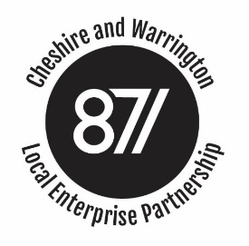

Paper for: The LEP Board
Title: Agenda Item 6 – Local Assurance Framework
Date: 16 September 2020
Strategic Purpose: Ensuring Governance and providing Assurance
Resource Implications: None
LEP Board: To approve the revised version of the Local Assurance Framework.

- As part of the governance arrangements, LEPs are required to publish and keep up to date a Local Assurance Framework, which follows and complies with the National Local Assurance Framework for LEPs published by MHCLG.
- The Local Assurance Framework describes in greater detail how the LEP is established and the procedures it operates.
- Each year the LEP is audited, by Cheshire East BC, to provide assurance that the Local Assurance Framework meets those requirements and that the organisation follows the procedures it describes in its document. The s151 certifies to MHCLG annually that the standards are being met, which forms an essential tenet of the annual governance rating.
- In the past, the LEP has carried out a review and update around March or April, to incorporate changes in the National Local Assurance Framework, which are normally issued at that time. This year the National Framework did not change. However, the internal audit for 2019/20 made several recommendations, which we have included in this years’ revision.
- Most pertinent of those recommendations was to streamline the Local Framework, the document having become rather unwieldy by incorporating iteratively the annual changes and changes to the structure and operation of the LEP. The original documents had focussed on providing a governance framework for the Local Growth Fund programmes. The audit recommendations proposed reflecting better the broader activities of the C&WLEP including e.g. decision making in relation to investments by the Growing Places Fund and in the Enterprise Zone. Implementing these recommendations and updating some of the materials referred to has taken a little longer this year.
- Board members should be familiar with the content of Local Assurance Framework, because in setting out how we operate, it puts requirements on the decision-making processes exercised in sub-boards and the full board.
- In re-drafting this year’s revision of the Local Assurance Framework, we have consulted on the draft with Cheshire East BC, and whose support and assistance has been both constructive and welcome.
- The board is requested to approve the latest version of the framework.

