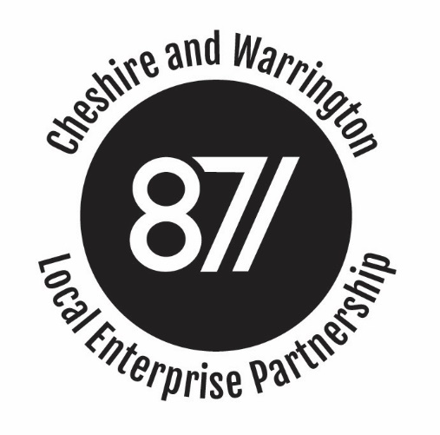

BOARD MEETING

Minutes of the Cheshire and Warrington Local Enterprise Partnership Board Meeting
held on 15th February 2017, CWaC HQ Building, 58 Nicholas Street, Chester CH1 2NP

Present:
Christine Gaskell (Chair) Cllr Samantha Dixon Cllr Rachel Bailey
Pete Waterman Meredydd David Robert Davis
Nigel Schofield Prof. Tim Wheeler Robert Mee
Philip Cox (LEP Chief Executive)

Apologies:
Howard Hopwood Cllr Terry O’Neill Clare Hayward
Louise Morrisey Martin Ashcroft Ged Barlow

Attending / Observing:
Charlie Seward Mark Livesey Kerry Billington
Andy Farrall Katrina Michel

Agenda Item 1: Apologies and Introductions

1.1 Christine Gaskell welcomed Board members to HQ, Cheshire West and Chester. Apologies were received from Cllr Terry O’Neill, Clare Hayward, Howard Hopwood, Martin Ashcroft, Ged Barlow and Louise Morrissey.

Agenda Item 2: Conflicts of Interest

2.1 No conflicts of interest were declared in relation to Agenda Items on the open section of the meeting.
Agenda Item 3: Public Presentation
3.1 No request from a member of the public had been received seven days before the meeting.
Agenda Item 4: Minutes of the Meeting held on 7th December 2016
4.1 The minutes were agreed as a true and accurate record.
Agenda Item 5: Chief Executive's report
5.1 The Board noted the report and additional comments from the Deputy Chief Executive and:
- Welcomed the LGF 3 allocation of £43.28m, noting this was a strong outcome and per capita was [amongst] the best achieved by any LEP;
- Welcomed the launch of the Industrial Strategy and the recognition the strong role the region had to play in it, by the PM’s and full Cabinet’s visit to the region that day. Christine had played a key role in anchoring the LEP in that announcement appearing on BBC Breakfast and other media outlets that day;
- Recognised the shift in government position in the recently released Housing White paper. The preoccupation with home ownership, had been replaced with a concentration on delivering the numbers across a range of tenures and accelerating delivery where possible into this Parliament. There was also a clear shift to disrupt the market, by encouraging new entrants and greater involvement of SMEs together with the promotion of different delivery models. The Board were particularly interested in Modern Methods of Construction and learning from European experience. A number of Board members had recently received a presentation on the Farmer Review of the construction sector and it was agreed that that presentation would be brought to the next Board meeting. Action: LEP Executive;
- Noted that Warrington Borough Council had formally accepted the proposal to secure a devolution deal on a Cheshire and Warrington footprint. A good deal of work was already underway on pulling together revised deal text, that would acknowledge the changing landscape since the last draft deal had been submitted ie Brexit, the Northern Powerhouse and the publication of the Industrial Strategy and Housing White paper. A dedicated team had been set up that would reside at Wyvern House and the Board would be kept updated as progress was made;
- Arrangements for MIPIM were well advanced. Promotional collateral was in place and a round table with Estates Gazette had been held that morning. Sponsorship had been confirmed from a number of local businesses and the Board agreed that the event would provide a strong chance to promote the investment opportunities across the region and, in particular, the Northern Gateway Development Zone and the Cheshire Science Corridor to a far-reaching audience;
- Welcomed the attendance of Andrew Percy at the launch of Protos which again had shone a spotlight on the success being delivered on the Enterprise Zone.
Agenda Item 6 & 7: Strategic Economic Plan Refresh & Industrial Strategy
6.1 The Chief Executive took the following two agenda items together by taking the Board through the presentation circulated with the Board papers on the Industrial Strategy and the SEP.
6.2 In discussion the following points were made:
- The LEP would co-ordinate a response to the consultation on behalf of the sub-region;
- The revised SEP and activities across the sub-region were closely aligned to the Industrial Strategy and we had a strong story to tell in response to the challenge set by government;
- It was suggested that the structure of the refreshed SEP should mirror that of the Industrial Strategy, as the key components were all in place;
- While each of the ten pillars identified to drive forward the Industrial Strategy had some relevance across Cheshire and Warrington, a number had a particularly strong resonance;
- We should look to identify sector deals to put to government, such as around skills, energy etc. rather than wait to be invited to
  - We should look to identify opportunities, such as bidding for an Institute of Technology, Research Institution etc.
- We should identify opportunities to increase the engagement between the employers and apprenticeship providers to match the current and future demands;
- In terms of skills, there was strong interest in shaping an offer/deal with employers around providing opportunities for those falling outside of current provision. There has been a number of initiatives tried and tested around this in the Sub-Region and it was acknowledged that it was resource intensive but achieved successful outcomes. Action: LEP Executive to put this to the Employers Skills Board
- The LEP should identify opportunities to help facilitate sectoral discussions. The automotive sector provided a useful blueprint, but this was by no means replicated widely;
- Opportunities existed to think differently and on a sub-regional footprint, such as in areas of procurement. The devolution deal shouldn’t lose sight of these opportunities.

Agenda Item 8: Revised Assurance Framework
8.1 The Deputy Chief Executive briefed Board Members on the steps the LEP Executive had taken to respond to the updated National Assurance Framework (AF) for LEPs. It was noted that Cheshire and Warrington already meets many of the revised requirements, but that the current AF did not necessarily promote this and so in line with the new National Assurance Framework had: -
- Identified a Board member (Ged Barlow) to represent the SME sector;
- Revised the Local Assurance Framework to reflect the additional requirements and submitted that version to the Accountable Body for approval. Once approved the text would be circulated to Board Members;
- Accepted additional material needed to be uploaded to the LEP website to update on progress with funded projects and highlight the outputs being delivered;
- Made proposals for the establishment of an independent Overview and Scrutiny Committee.
8.2 The Board noted the deadline of 28th February 2017 for the LEP’s Accountable Body S151 Officer to confirm to Government that the LEP complies with the new requirements. The Board approved the proposed Overview and Scrutiny arrangements set out in the paper that had been circulated in advance of the meeting, but asked that arrangements were aligned to the future needs of a Combined Authority to avoid duplication further down the line.
Agenda Item 9: Board Sub-Committee Updates
9.1 The papers provided in support of Agenda Item 9 were noted.
Item 10: Any other business
10.1 Marketing Cheshire and recently been successful in bidding for a modest amount of funding to support tourism. Work was underway to pull together proposals for using that funding.
Date and Time of Next Meeting:
Wednesday 22nd March, 5.00pm.

Action points:
Action: LEP Executive to bring the Farmer Review presentation of the Construction Sector to the next Board Meeting

Action: Employers Skills Board to consider work around employers/NEETs/Care leavers

