LEP STRATEGY COMMITTEE – AGENDA ITEM 7
Subject: Cheshire and Warrington Evergreen Fund
Author: Rachel Brosnahan, Head of Programmes
Sponsor: Philip Cox, CEO
Meeting date: Friday 17th May 2019

- Purpose

To seek the approval of the Strategy Committee to set up a Cheshire and Warrington Evergreen Fund and approval to use up to £200k of retained business rates towards the initial running costs of the fund.

- Recommendations
The Strategy Committee is asked to: -
- Note the content of the report
- Approve the establishment of a Cheshire and Warrington Evergreen Fund
- Approve the use of up to £200k of retained business rates towards the first two years running costs of the fund.

- Executive summary
A North West Evergreen Fund was established in 2011 with £50m of ERDF to help delivery and support infrastructure projects and developments through loan or equity investments. The fund is now fully committed. Greater Manchester established their own Evergreen “2” fund is 2017 and the opportunity has arisen for Cheshire and Warrington to also do the same.

The underlying objective is to add £20 million to the existing Evergreen Fund, targeted at investments in Cheshire and Warrington. The nature of the European regulations however, means that the additional £20million will have to be structured as a legally separate fund with a remit to the fund managers to operate it in a way that, as far as borrowers are concerned, they are drawing from a single, North West wide, Evergreen facility.

The LEP has developed the ERDF application and in line with requirements gained approval from Cheshire East Borough Council (CEBC) to act as the accountable body. A funding agreement has now been signed by CEBC and MHCLG awarding £20m of ERDF grant to be spent by December 2023.

A Urban Development Fund (UDF) owned by CEBC will need to be established a fund management company recruited. The costs for establishing the fund are in part being borne by funds held by Evergreen 1 with the LEP meeting some of the costs. It is proposed that the initial running costs are funded by a grant from the LEP utilising retained business rates. Under the ERDF regulations a loan to the UDF is not permissible, although the funding could be repaid to the LEPS out of returns post 2031 under the regulations.

The Fund is expected to make it’s first investment by the end of the year with a total of between 5-8 investments made in total.

The fund is expected to help achieve £38m of private match funding with the full £20m ERDF grant funding being available from reinvestment from year 8, thereby creating a revolving fund for the sub-region.

- Background
An urban investment fund called The North West Urban Investment Fund was established in 2011 as the holding fund for Evergreen 1 and Chrysalis Fund. The Chrysalis fund was tasked with investing funding in the Liverpool City Region area and the Evergreen Fund I was established by a number of Local Authorities in the remainder of the Northwest area.

Evergreen 1 has been investing funding across the North West with the exception of Liverpool since 2011. The fund is now fully committed, with Cheshire and Warrington having received £37m of investment. The fund which originally had a £50m ERDF grant which was matched by land and cash from the NW Regional Development Agency has been extremely successful with the loan book sold to a pension fund generating further income for investment. Greater Manchester set up an Evergreen 2 fund for investment in Greater Manchester in 2017.

The Evergreen 1 Board is Co-Chaired by the Chief Executive of Manchester City Council and Lancashire County Council. The local authorities and the GM Core Investment Team are responsible for supporting the development of the fund’s project pipeline. The fund is managed by CB Richard Ellis (CBRE), a property advisory consultancy that provides a wide range of agency, asset management and property finance services.

- Cheshire and Warrington Evergreen Fund (CWEGF)

  - What it is
The proposed CWEGF is a £20m fund which will act as a sister fund to the Evergreen 1 fund established in 2008 and the Greater Manchester Evergreen 2 fund. The Evergreen 1(EG1) fund was very successful and part of the loan book was sold on to a pension fund proving further funding for investment. Cheshire and Warrington received £37m (some of this is still final assessment) from the fund which is now fully invested.
The EG1 fund has proven to be a very useful tool to promote and development. The opportunity to bid for funding arose in 2017 and the ex-ante reports were commissioned which showed demand for a new fund.
MHCLG requirements are that they can only receive bids from accountable bodies to run a “Financial Instrument”. We therefore asked Cheshire East Council if they would be the applicant for the fund and we sought legal advice on the most appropriate structure.
CEC agreed to be the applicant and legal advice showed that a new company would have to be established which would have to be owned by CEC which they have also agreed to in principle.
The proposed structure is:

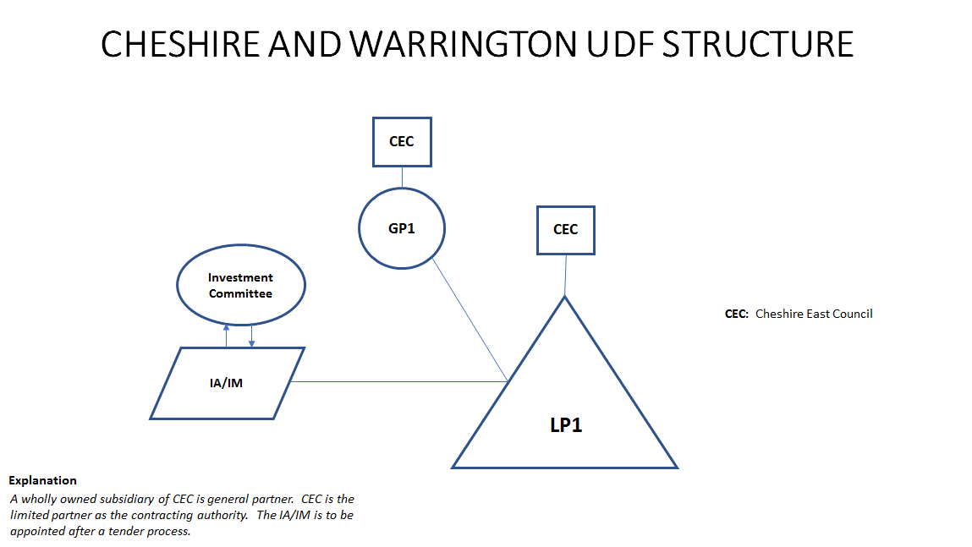
GP: General Partner, LP: Limited Partner
  - What will it do?
In line with level of investments made by EG1, it is expected that the fund will only make 5-8 investments with the £20m of ERDF. Further investments are expected as the funding is recycled.
The funding will be invested against three ERDF priorities in the following quantities:
- £7m PA1 (research and innovation) e.g. new labs and technical spaces
- £5m PA3 (business support) – for SMEs to grow and develop
- £8m PA4 (low carbon) - to fund energy efficiency property developments or retro fit existing property developments.

  - How it will be delivered
The project will be delivered in part by three bodies. Their respective roles and responsibilities are set out below:
    - The LEP
The LEP will deliver the following services:
- Manage the procurement of the fund manager
- Manage the fund manager contract once appointed, to include monthly monitoring.
- Monitor the achievement of outputs and investment rates
- Ensure that the Fund manager cross refers enquiries to the Greater Manchester and Liverpool Evergreen funds, the LEP’s GPF fund and Enterprise Zone as appropriate
- Co-ordinate the appointment of the directors to the UDF board
- Be responsible for ensuring board members declare any conflicts of interest and declare any gifts and hospitality
- Organise the board meetings including preparation and circulation of papers and minute the meetings.
- Prepare the claims to MHCLG
- Prepare the quarterly monitoring reports to MHCLG
- Keep all the records in connection with the fund in accordance with the document retention policy included in the application.
- Approve the drawdown notices from the fund manager
- Send approved drawdown notices to CEC for payment to the fund manager (as per GPF and LGF payment process)
- Visit the fund managers offices annually to check record keeping is line with ERDF requirements
- Manage all the publicity and marketing of the fund in conjunction with the fund manager.
- Provide £200k towards the initial running costs of the UDF

    - Cheshire East Borough Council (CEBC) [subject to refinement and agreement]
CEBC will deliver the following services:

- Approve the establishment of the UDF company
- Manage and produce the UDF company accounts
- Arrange for the annual audit of the accounts and filing at Companies house
- Carry out an annual internal audit
- Countersign:
  - Drawdown notices
  - MHCLG claims
  - MHCLG monitoring reports
- Set up a separate account for management of the UDF funds
- Manage and account for the receipt of capital and interest payments from investments
- Monitor the interest payments and notify the LEP if any payments are missed
- Manage the idle funds to maximise the interest earned
- Manage all records in line with the document retention policy appended to the Grant Funding Agreement

    - Fund Management Company (To be appointed)
The Fund management company will deliver the following services:
- Market the fund
- Work alongside funds operating in Manchester and Liverpool to cross refer applicants
- Develop applications and make recommendations to the UDF for approval
- Issue contracts to successful applicants
- Monitor the financial performance of the investments and gather output evidence from the applicant.

  - Benefits and outcomes
The benefits of a Cheshire and Warrington UDF are that there will be another means to support investment in the region now that EG1 is fully invested and that the Growing Places fund is almost fully invested for the time being.
The ERDF will attract private finance and the returns on investments will be reinvested created an Evergreen Fund for the region.
The outputs expected to be generated are:
- Private Sector Leverage £38m
- Commercial floorspace created or renovated 20,000sqm
- Reduction in Greenhouse Gases 6045 tonnes by 2024

The outputs were calculated using figures achieved by Evergreen 1 investments and low carbon schemes in Cheshire and Warrington.

The project also provides a means for investing ERDF especially the priority 4 low carbon Funding where it was proving difficult to generate applications and therefore this funding was at risk of being lost.

  - Costs of delivery
The costs of managing the fund will, in the medium term, be met by the interest income receipts generated by the fund investments. However, the initial period, expected to be a maximum of two years, requires funding. Unfortunately, ERDF rules effectively prevent us from lending the fund money, to be repaid later, and we are therefore seeking in principle agreement to use EZ funds as a grant. This was discussed, and received support, at the Board Meeting in March.
Initial high-level financial modelling has been carried out with a “net” cost range between £150k and £200k over two years, with the burden falling heaviest in year one until investment income starts to flow. The figure estimated for fund manager fees of £100k pa, but which can only be firmed up following a tender process. The estimate has been based on the costs of running the GM Evergreen Fund, which is £60k p.a. albeit for a lower level of service CEC have confirmed that they will charge £30k for the first year and £20k in subsequent years, with costs to increase in line with the Retail Price Index.
The newco once established will be able to draw down 25% of the ERDF grant, i.e. £5m and it is expected that some of the interest earned from the idle funds will help meet the running costs of the fund, coupled with the interest payments received on the loans made.
At the top end of the range, running costs for the first two years are conservatively estimated at £200k. It is requested that the LEP provides this funding out of the retained business rates. The funding could be repaid to the LEP but the ERDF regulations state that this can’t be until after 2031, so it will essentially be a grant to the fund.
The modelling indicates that the fund will be self sufficient after year 2 but this is dependent on an investment being made this year.
The costs of establishing the fund are estimated at £100k and are being part funded by funding held from Evergreen 1. This funding is being used to cover the costs of the ex-ante reports and the legal and procurement advices and support.
- Key milestones
- CEC to seek cabinet approval to establish UDF
- Establish UDF:
  - Appoint legal firm to complete necessary work (or CEC?)
  - complete MEMARTS,
  - register with Companies House
  - appoint board members (need appointment letters)
  - Draft TORs of board
  - PEV likely to be carried out
- Complete procurement documents:
  - Part 1 and part 2 of ITT need completing
  - Fund manager agreement to be drafted
  - IOGs Complete
  - Idle Funds policy complete
  - Document retention policy complete
- Appoint fund manager
  - Fund manager to develop application material
  - Launch fund
  - Make first investment

