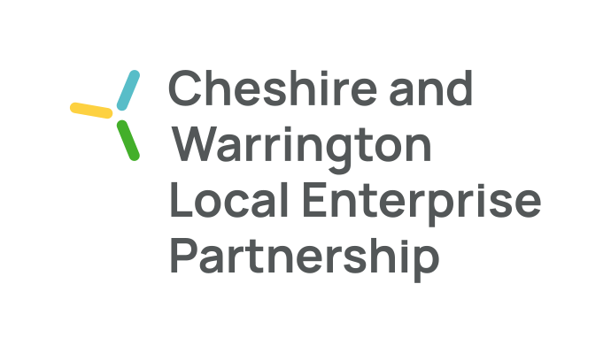
Engagement Board Meeting Notes – 30th May 2022

The following people attended the meeting (full board):
- Maggie Chen - (Chair)
- Yulanda Duff – (Deputy Chair)
- Katie McConnell
- Connor Diskin
- Joe Toward

The main purpose of the meeting is to:
- Provide an update on the progress of the recruitment video
- Discuss the outcome of the Employers’ Skills and Education Board, Impact measures document

20.00hrs Welcome (5 mins)

20.05 hrs Recruitment campaign update
- Video still in progress – we are waiting on the template. The idea is for us to slot in our personalised videos into the template once it is sent to us.
- As our in-person meeting could not go ahead, the aim is now for individual EB members to capture 5 second video at an iconic Cheshire landmark

20.15 hrs Employers’ Skills and Education Board - Impact measures (45 mins)
- EB members reviewed the Impact Measures document written by the ESEB in depth.
- How is the impact being assessed?
- Who is measuring the impact?
- The above two questions were the biggest talking point between EB members – the paper doesn’t make clear the goals of the impact measures
- The “measurement” column doesn’t make clear what the metrics are for the success measures – oftentimes the end goal is restated without breaking down what success actually looks like in numbers
- The measurements need to be quantifiable in order to identify impact further down the line – need better links between the challenge and the goal.
- E.g. Point 5 – the attainment gap between children who get FSM and those who don’t
- Do we need a central impact measurement guideline/framework by the LEP Strategy Board that is then adapted by each sub-board?
- How to maximise efficiency when creating impact measures?

AOB
North West Net Zero Youth Network – pending new information.

Meeting end.

