Blue Orchid
27 November 2020

Recovery & Restructure Grant
Week 3 Report
Abstract
A brief yet important read providing a “bullet point” commentary of the third week of delivery since launch of the service.

Achievements Summary

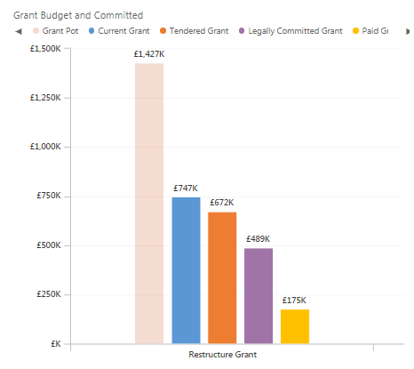
- We have now opened 2 application rounds following the project extension award, these rounds have been fully committed within very short periods of time, usually a few hours.

- We have paid £175,000 of grants out to SMEs and have issue offer letters to a further £489,000.

- We have streamlined the process for those seeking grants from off the shelf items by utilising benchmark data and our own product searches to create standardised award values and therefore remove the need for 3 quotes for all applicants.

Grant Allocation by Local Authority
The pie charts below show for each Local Authority the number of clients at each stage of the grant delivery process. So for example, the top left pie shows the waiting list of clients. The bottom middle pie shows the grants awarded, but not yet paid is 35, of which 19 are Cheshire West & Chester businesses.
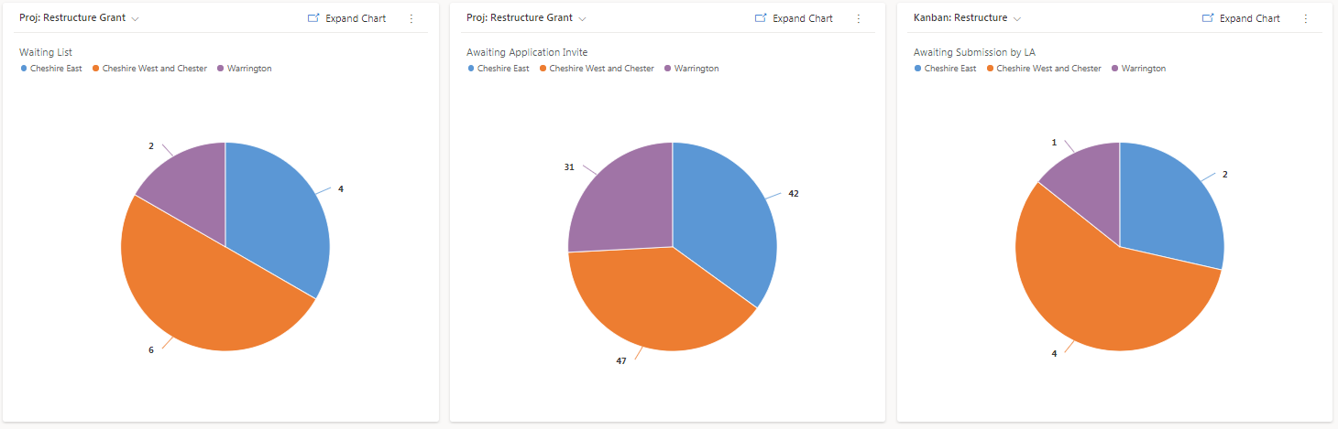

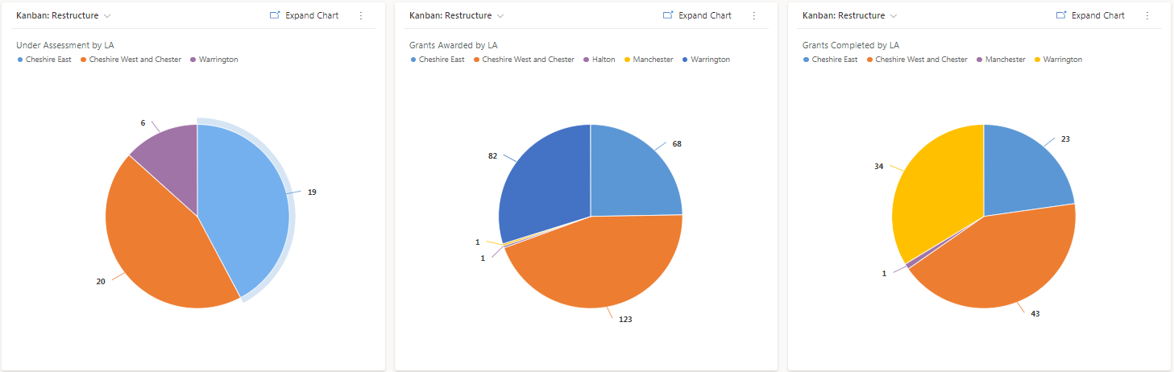

The chart below shows award value and grant beneficiaries by sector, note Tourism, Retail have benefitted most, showing our focus on these critically hit sectors.

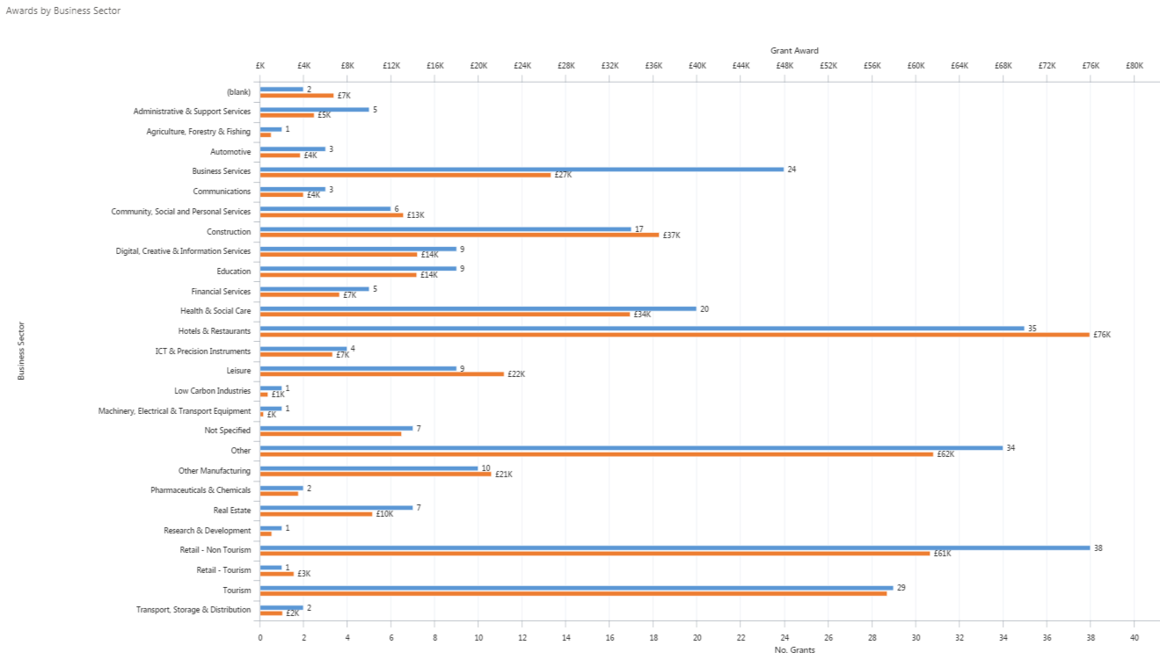

The Chart below shows the number & values of grant awarded against sector & No. of staff furloughed.

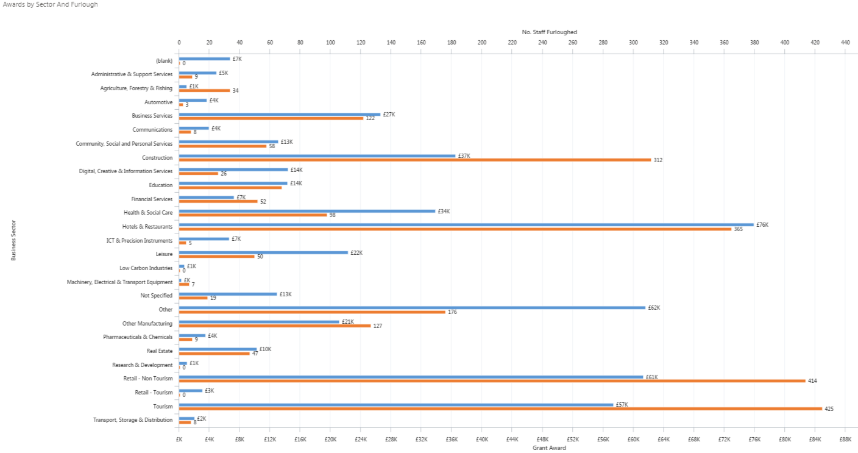

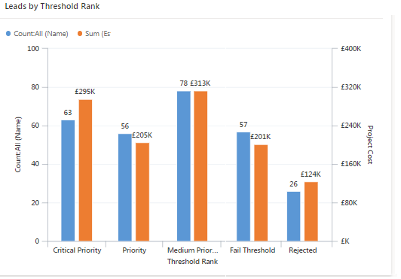

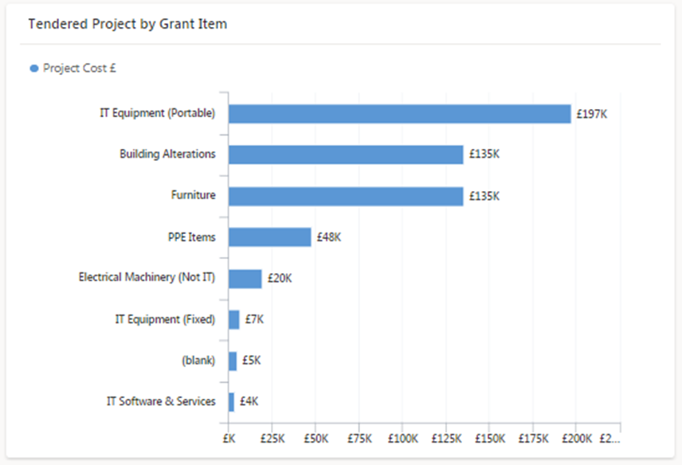
This chart shows the approval of grant applications against our assessment of the need, based on Covid impact on staff, turnover etc, sector & business confidence.

The chart illustrates the breakdown of grant awards by the type of expenditure. This shows that the largest amounts of grant expenditure have been on ICT equipment, to support remote working and electronic payments and building alternations & furniture to adapt businesses to the social distancing requirements and increase outdoor capacity.

The Image below shows the distribution of the grant awards across the Cheshire & Warrington LEP area.

