Blue Orchid
11 Sept 2020

Recovery & Restructure Grant
Week 6 Report

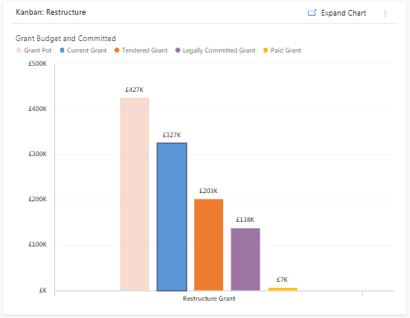
- We are currently dealing with 159 formal grant applications, and as we continue to work with clients to better understand their needs are able to cap the maximum grant for some non-critical sectors. As such our advisors have been working hard to ensure we can stretch the budget to reallocate resources to those currently on the waiting list
- The focus implemented on the retail, hospitality, leisure sectors had the desired result of the increasing the applications being processed from these sectors. However they generally take longer to progress due to the complexity in the projects they are implementing.
- We have awarded £140,332 of grants to 77 applicants and have paid £7,134 worth of grants.

Grant Allocation by Local Authority
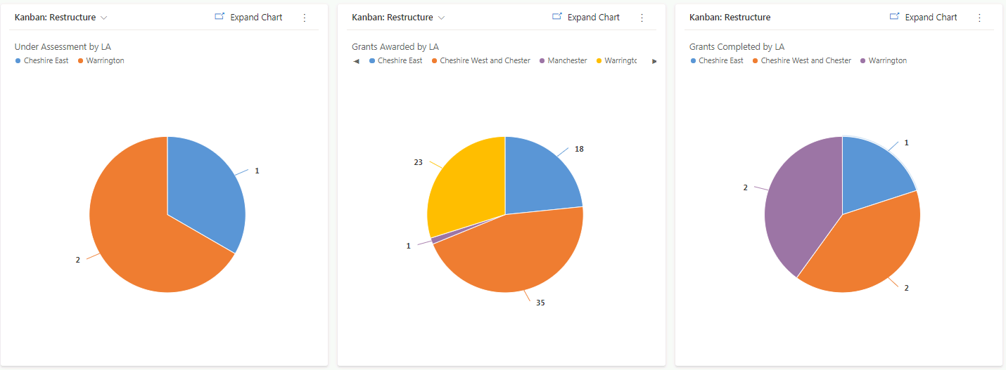
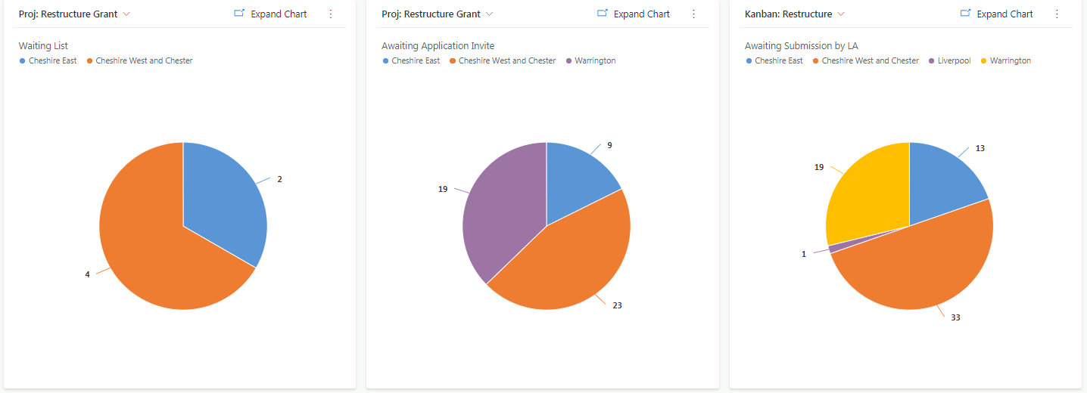
The pie charts below show for each Local Authority the number of clients at each stage of the grant delivery process. So for example, the top left pie shows the waiting list of clients.

Grant Awards by Business Sector
The chart below shows award value and grant beneficiaries by sector, note Tourism, Retail have benefitted most, showing our focus on these critically hit sectors.
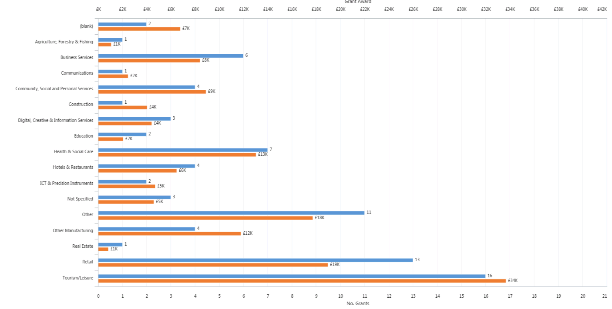

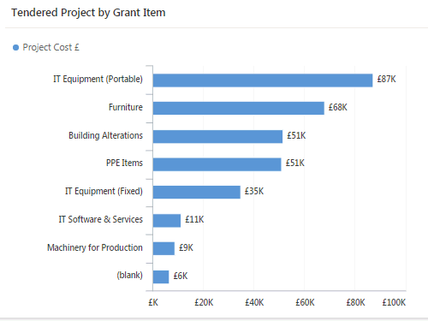
Tendered Project by Grant Item
As can be seen the programme has applications for a range of Covid related expenditure including ICT which includes both remote working and payment solutions technology, Outdoor seating & building fabric changes (primarily outdoor areas) and fixed PPE.

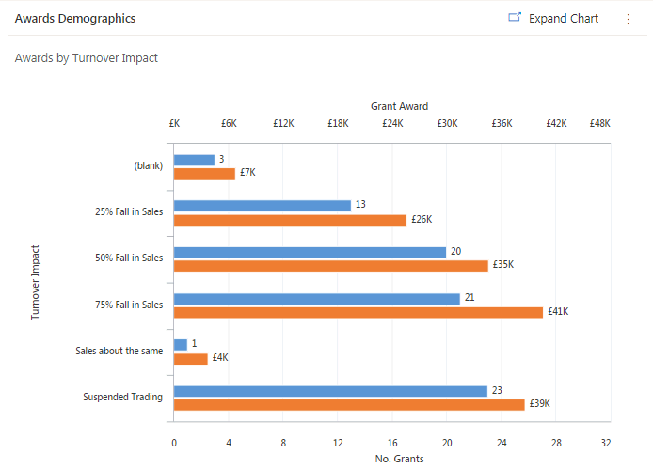
Grant Awards by Turnover Impact
As can be seen the greatest number of the grant awards have been awarded to businesses that have declared greater than 50% fall in sales due to covid.

